Ex No: 6
Design backend part of the application using Django Framework

Aim:

To design the backend of your application using Python Django

Code:

models.py

from django.db import models

class HotelBooking(models.Model):
name = models.CharField(max_length=100)
hotel_name = models.CharField(max_length=100)
check_in = models.DateField()
check_out = models.DateField()

class TransportBooking(models.Model):
name = models.CharField(max_length=100)
transport_type = models.CharField(max_length=50)
date = models.DateField()
source = models.CharField(max_length=100)
destination = models.CharField(max_length=100)

view.py
from django.shortcuts import render, redirect
from .forms import HotelBookingForm, TransportBookingForm
from .models import HotelBooking, TransportBooking

def book_hotel(request):
if request.method == 'POST':
form = HotelBookingForm(request.POST)
if form.is_valid():
form.save()
return redirect('hotel_list')
else:
form = HotelBookingForm()
return render(request, 'hello/bookhotel.html', {'form': form})

def hotel_list(request):
bookings = HotelBooking.objects.all()
return render(request, 'hello/booking.html', {'bookings': bookings})

def book_transport(request):
if request.method == 'POST':
form = TransportBookingForm(request.POST)
if form.is_valid():
form.save()
return redirect('transport_list')
else:
form = TransportBookingForm()
return render(request, 'hello/transport.html', {'form': form})

def transport_list(request):
bookings = TransportBooking.objects.all()
return render(request, 'hello/tourbook.html', {'bookings': bookings})
forms.py

from django import forms
from .models import HotelBooking, TransportBooking

class HotelBookingForm(forms.ModelForm):
class Meta:
model = HotelBooking
fields = '__all__'

class TransportBookingForm(forms.ModelForm):
class Meta:
model = TransportBooking
fields = '__all__'

urls.py

from django.urls import path
from . import views

urlpatterns = [
path('bookhotel/', views.book_hotel, name='book_hotel'),
path('hotels/', views.hotel_list, name='hotel_list'),
path('booktransport/', views.book_transport, name='book_transport'),
path('transports/', views.transport_list, name='transport_list'),
]
Screenshots

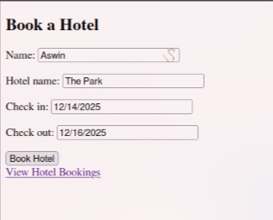

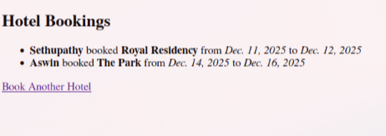
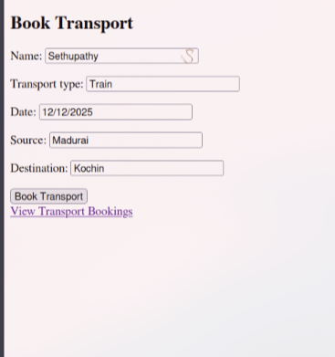
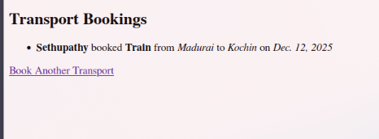
Result:
Thus , the implementation Django Framework im our application was successful.

